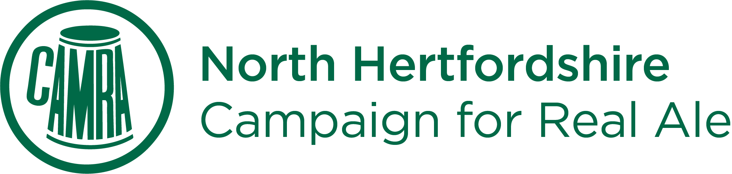
Back to the pub!
Where is open in April? What we know as of April 23rd.

Tell us what you know by commenting on our website. We’ll update regularly.

Anstey
Blind Fidler
Ardeley
Jolly Waggoner
Ashwell
Bushel & Strike
Three Tuns
Aspenden
Fox
Aston End
Crown
Baldock
Cock – 17th May
Engine
George IV
Hen & Chickens – 2pm 12th
Old White Horse
Orange Tree
Victoria
White Hart
White Lion

Barley
Chequers
Fox & Hounds – 14th
Barkway
Tally Ho
Benington
Lordship Arms – noon 18th May
Bragbury End
Chequers
Braughing
Axe & Compasses
Brown Bear – 11am 12th
Breachwood Green
Red Lion
Brent Pelham
Black Horse
Buntingford
Crown
Dane End
Boot – 5pm 12th

Furneux Pelham
Brewery Tap
Gosmore
Bull – 5pm 14th
Great Hormead
Three Tuns 5pm 15th
Great Wymondley
Green Man
Halls Green
Rising Sun
Hinxworth
Three Horseshoes
Hitchin
Albert
Angel Vaults Inn
Angels
BB’s Bar
Beer Shop – open as a takeaway
Bricklayers
Cinnabar
Coopers Arms
George
Half Moon
Highlander
Kite at The Red Hart
Orange Tree
Pitcher and Piano
Radcliffe
Three Moorhens
Victoria – 13th
Ickleford
Old George
Knebworth
Station
Letchworth
Arena Tavern
Crafty’s
Garden City Brewery
Platform – 17th May
Two Chimneys – 17th May
Little Wymondley
Bucks Head
Plume of Feathers
Norton
Three Horseshoes
Nuthampstead
Woodman
Old Knebworth
Lytton Arms
Pirton
Fox
Motte & Bailey
Preston
Red Lion
Royston
Banyers
Green Man (no real ale)
Heath Café Bar
Jolly Postie
Manor House
Old Bull Inn
St Pauls Walden
Strathmore Arms

Stevenage
Chequers – 13th
Coach and Horses
Coopers - Noon 16th
Marquis of Lorne
Marquis of Granby – noon 19th
Old Town Bar
Our Mutual Friend
Pear Tree – 16th
Pied Piper – 17th May
Red Lion
Standing Order
Tom Tiddlers Tavern
Therfield
Fox & Duck – 5-30pm 16th
Walsworth
Millstream
Weston
Cricketers
Willian
Fox
Three Horseshoes

